Cardiff and Vale Local Public Health Team
Sexual health bulletin: December 2021

The C-Card Scheme provides condoms and sexual health information for young people aged 13 – 25. To find out more visit https://www.ymcacardiff.wales/about/what-we-do/health-wellbeing/c-card-scheme/ or call 02920 465 250 / email shot@ymcacardiff.wales
Frisky Wales provide a postal service delivering free condoms https://www.friskywales.org
The Department of Sexual Health offer condom collection from Cardiff Royal Infirmary. To access this service an online form needs to be completed first https://cavuhb.nhs.wales/our-services/sexual-health/

Community Pharmacy Oral Contraception service
Women can now access oral contraception at selected pharmacies across Cardiff and the Vale of Glamorgan, either independently or by referral from a health care professional.
For more details visit: https://cavuhb.nhs.wales/news/home-page-news/oral-contraception-is-now-available-at-these-pharmacies-within-cardiff-and-the-vale/

Visit www.friskywales.org to order a free postal test kit. The Public Health Wales website also has a self-assessment tool to help assess risk and find local services as well as information on relationships, sexual health and contraception.

The Department of sexual health
Tel 02921 835208 Monday to Friday- 9.00am-3.00pm
A walk in service is no longer operating for general sexual health treatment. If someone has symptoms or they are concerned they have an STI call the Department of Sexual Health. A member of staff will take details and a clinician will call back. If urgent, an appointment may be booked to attend the department the same day. Alternatively, a face to face or video consultation may be booked on another day.
For full details and Christmas opening times visit https://cavuhb.nhs.wales/our-services/sexual-health
Under 18’s Walk- in Clinic at Department of Sexual Health
A dedicated walk in clinic for young people aged 18 and under every Tuesday from 2-5pm at Department of Sexual Health,
Cardiff Royal Infirmary, Glossop Road, Cardiff, CF24 0SZ.
For more details visit: https://cavuhb.nhs.wales/our-services/sexual-health

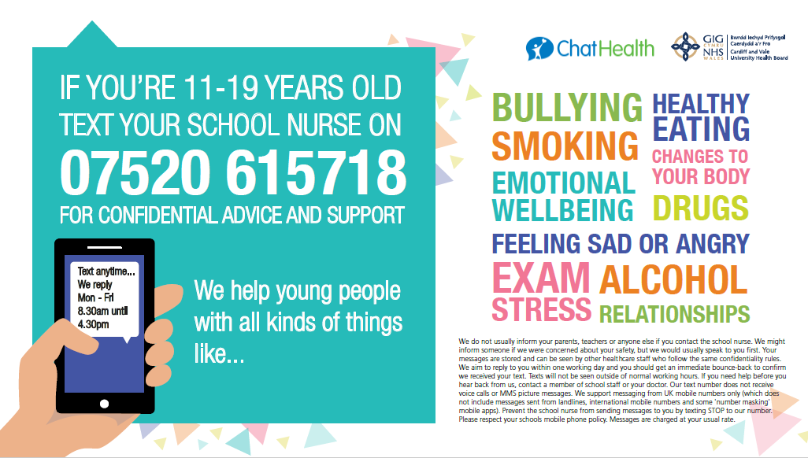

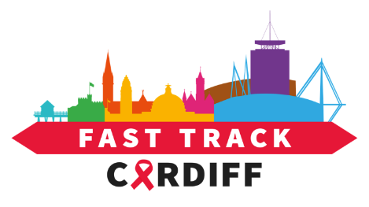
Visit https://fasttrackcardiff.wales/2021/12/06/fast-track-cv-december-2021-update-bulletin-6/ for Fast Track Cardiff’s latest bulletin including information about:
HIV testing week took place in November. The campaign aims to break down the stigma that prevents people from testing, show how easy it is to get tested and link people to the national free postal testing portal. Social media assets are available to promote HIV testing all year round.
The GP facilitated HIV home testing pilot in Cardiff City & South GP cluster has been evaluated. Patients over the age of 16 were sent a text message inviting them to take a HIV test. The success of the pilot has resulted in funding to extend the project across Cardiff and Vale.

Mural in James Street, Butetown promoting HIV testing

